PROMPT:

I want you to conduct a comprehensive, end-to-end technical review of the API codebase located in apps/api.

Objective: Determine whether this codebase meets the standards of a production-grade, foundational API framework that can serve as the baseline for any future API-based projects. The intended outcome is that future work should require changes only in apps/api/src/features (either modifying existing features or adding new ones), with all other foundational aspects already implemented and reliable.

Evaluation Criteria: Review the codebase across the following categories and score each area from 0–5 (0 = missing, 5 = excellent/complete). Include clear evidence from the code for each score.

Architecture & Modularity:

- Separation of concerns between infrastructure and features

- Ease of extending or replacing components

Persistence & Data Layer:

- Database abstraction and ORM/ODM quality

- Migration strategy and transaction safety

Security:

- Authentication & authorization mechanisms

- Input validation and sanitization

- Secure defaults and dependency hygiene

Rate Limiting & Abuse Prevention:

- Implementation completeness

- Configurability and granularity

Performance & Scalability:

- Efficient request handling

- Caching, connection pooling, async handling

Error Handling & Logging:

- Clear, consistent error responses

- Centralized logging and monitoring hooks

Testing & CI/CD:

- Test coverage and quality (unit/integration)

- Continuous integration setup

Documentation & Developer Experience:

- API documentation quality (OpenAPI/Swagger)

- Setup instructions and onboarding ease

Maintainability & Future-Proofing:

- Consistent coding patterns and naming

- Dependency management and upgrade readiness

Report Format:

Please return your findings in the following structure:

1. Executive Summary:

- One-paragraph verdict: Does this codebase currently meet the stated goal?

2. Scorecard:

- Columns: Category | Score (0–5) | Key Observations

Category column values:

- Architecture & Modularity

- Persistence & Data Layer

- Security

- Rate Limiting & Abuse Prevention

- Performance & Scalability

- Error Handling & Logging

- Testing & CI/CD

- Documentation & DevEx

- Maintainability & Future-Proofing

3. Strengths:

- List specific strengths with supporting examples from the code.

4. Gaps & Risks:

- List specific shortcomings, missing features, or risky design decisions.

5. Recommendations:

- Short-term fixes (quick wins)

- Long-term improvements (strategic changes)

Important Instructions:

- Use direct evidence from the code; avoid assumptions.

- Be specific about file paths, functions, or modules when citing examples.

- Avoid generic advice—tie all feedback to this specific codebase.

- Assume this evaluation will be used to decide if the repository is ready for production as-is.

Grok 4:

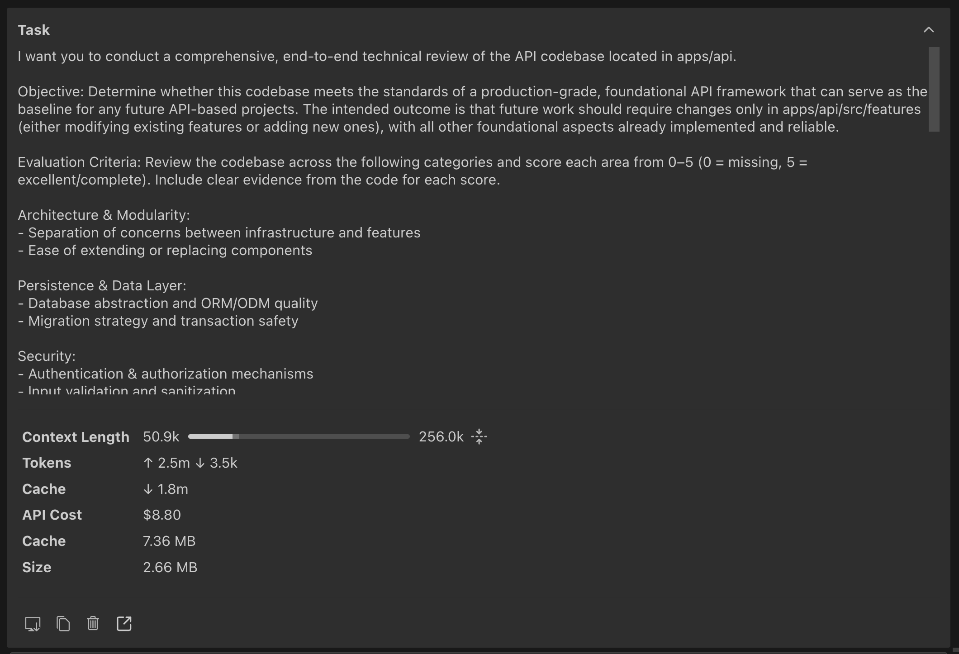

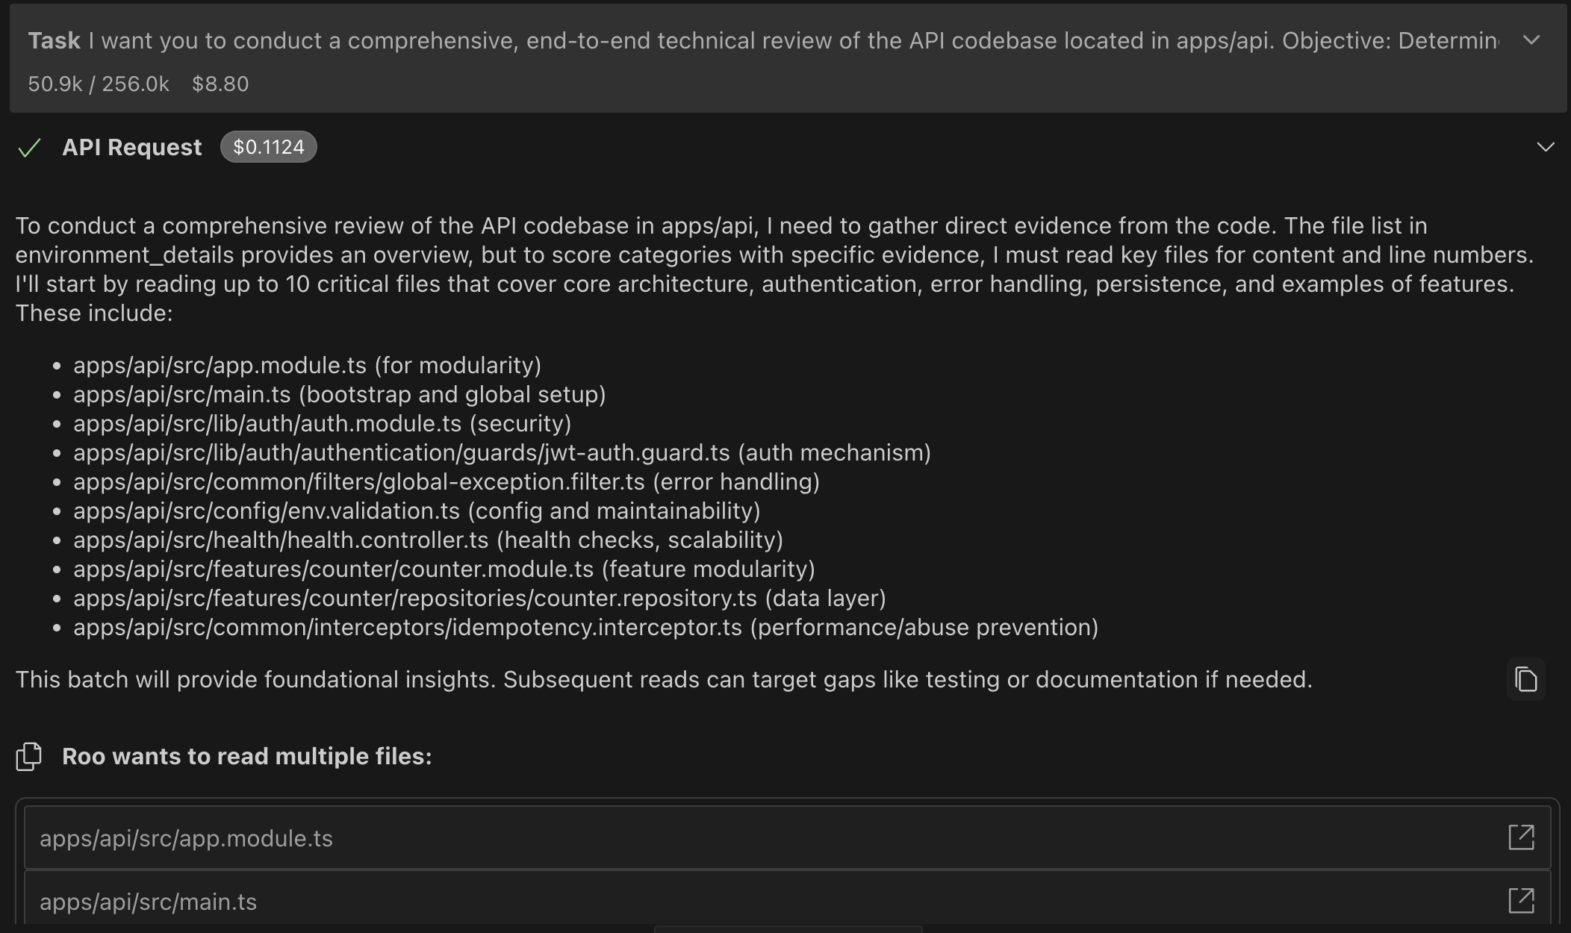

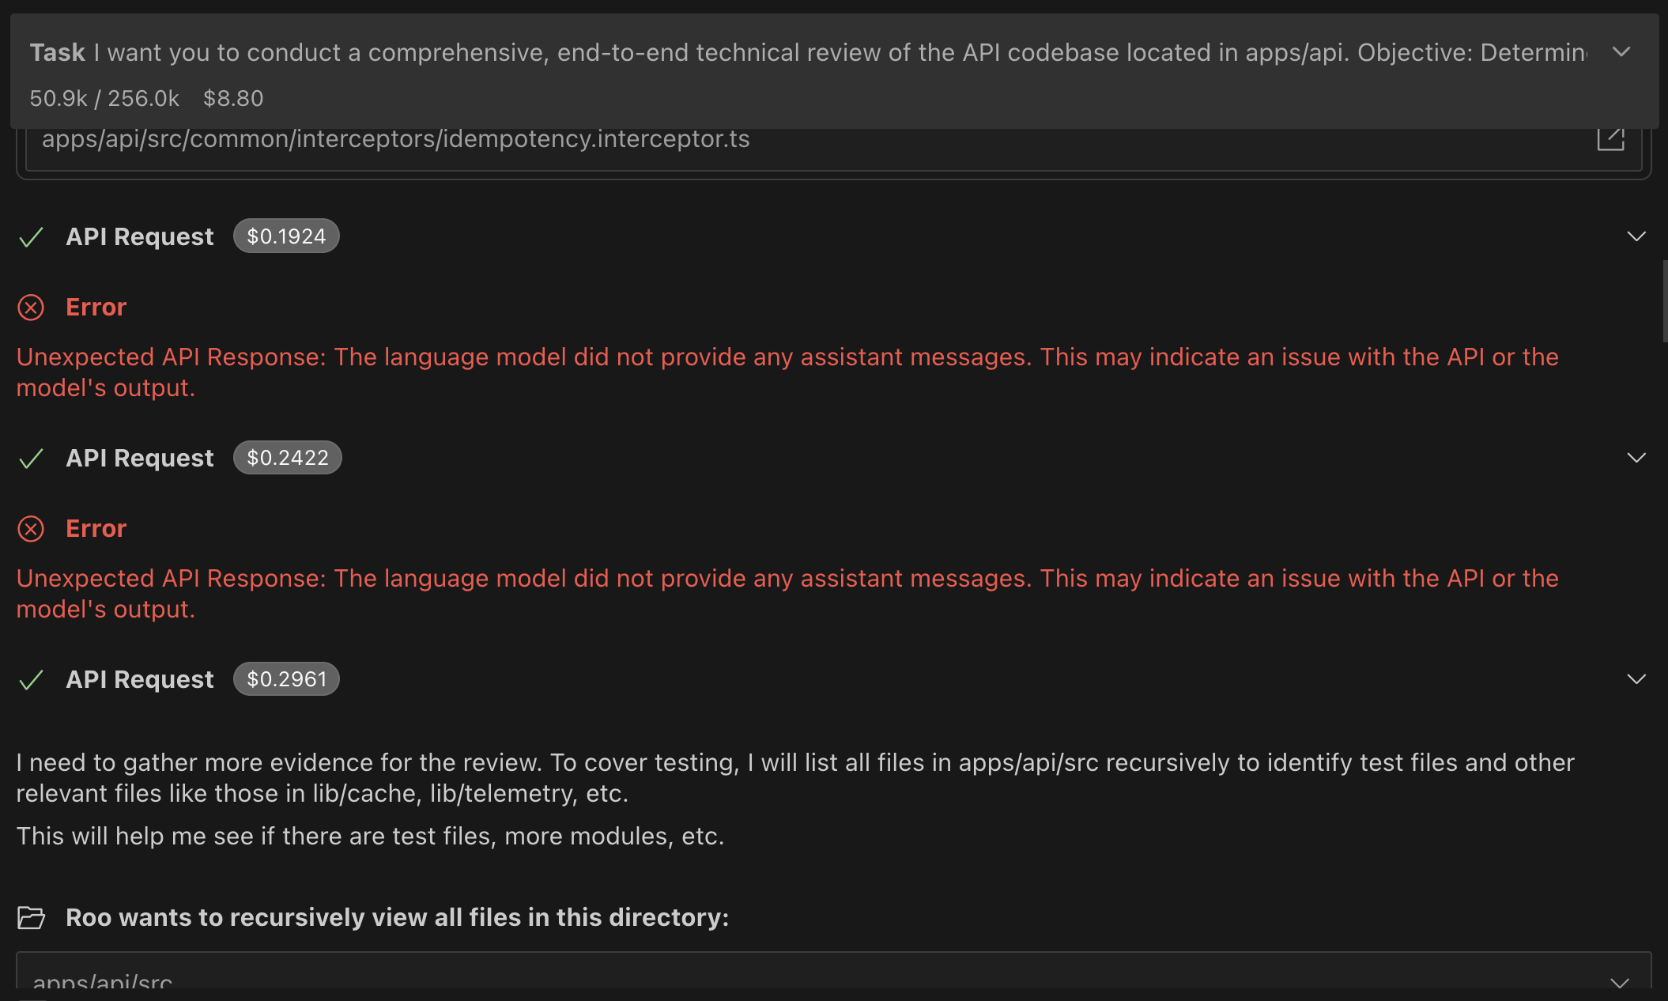

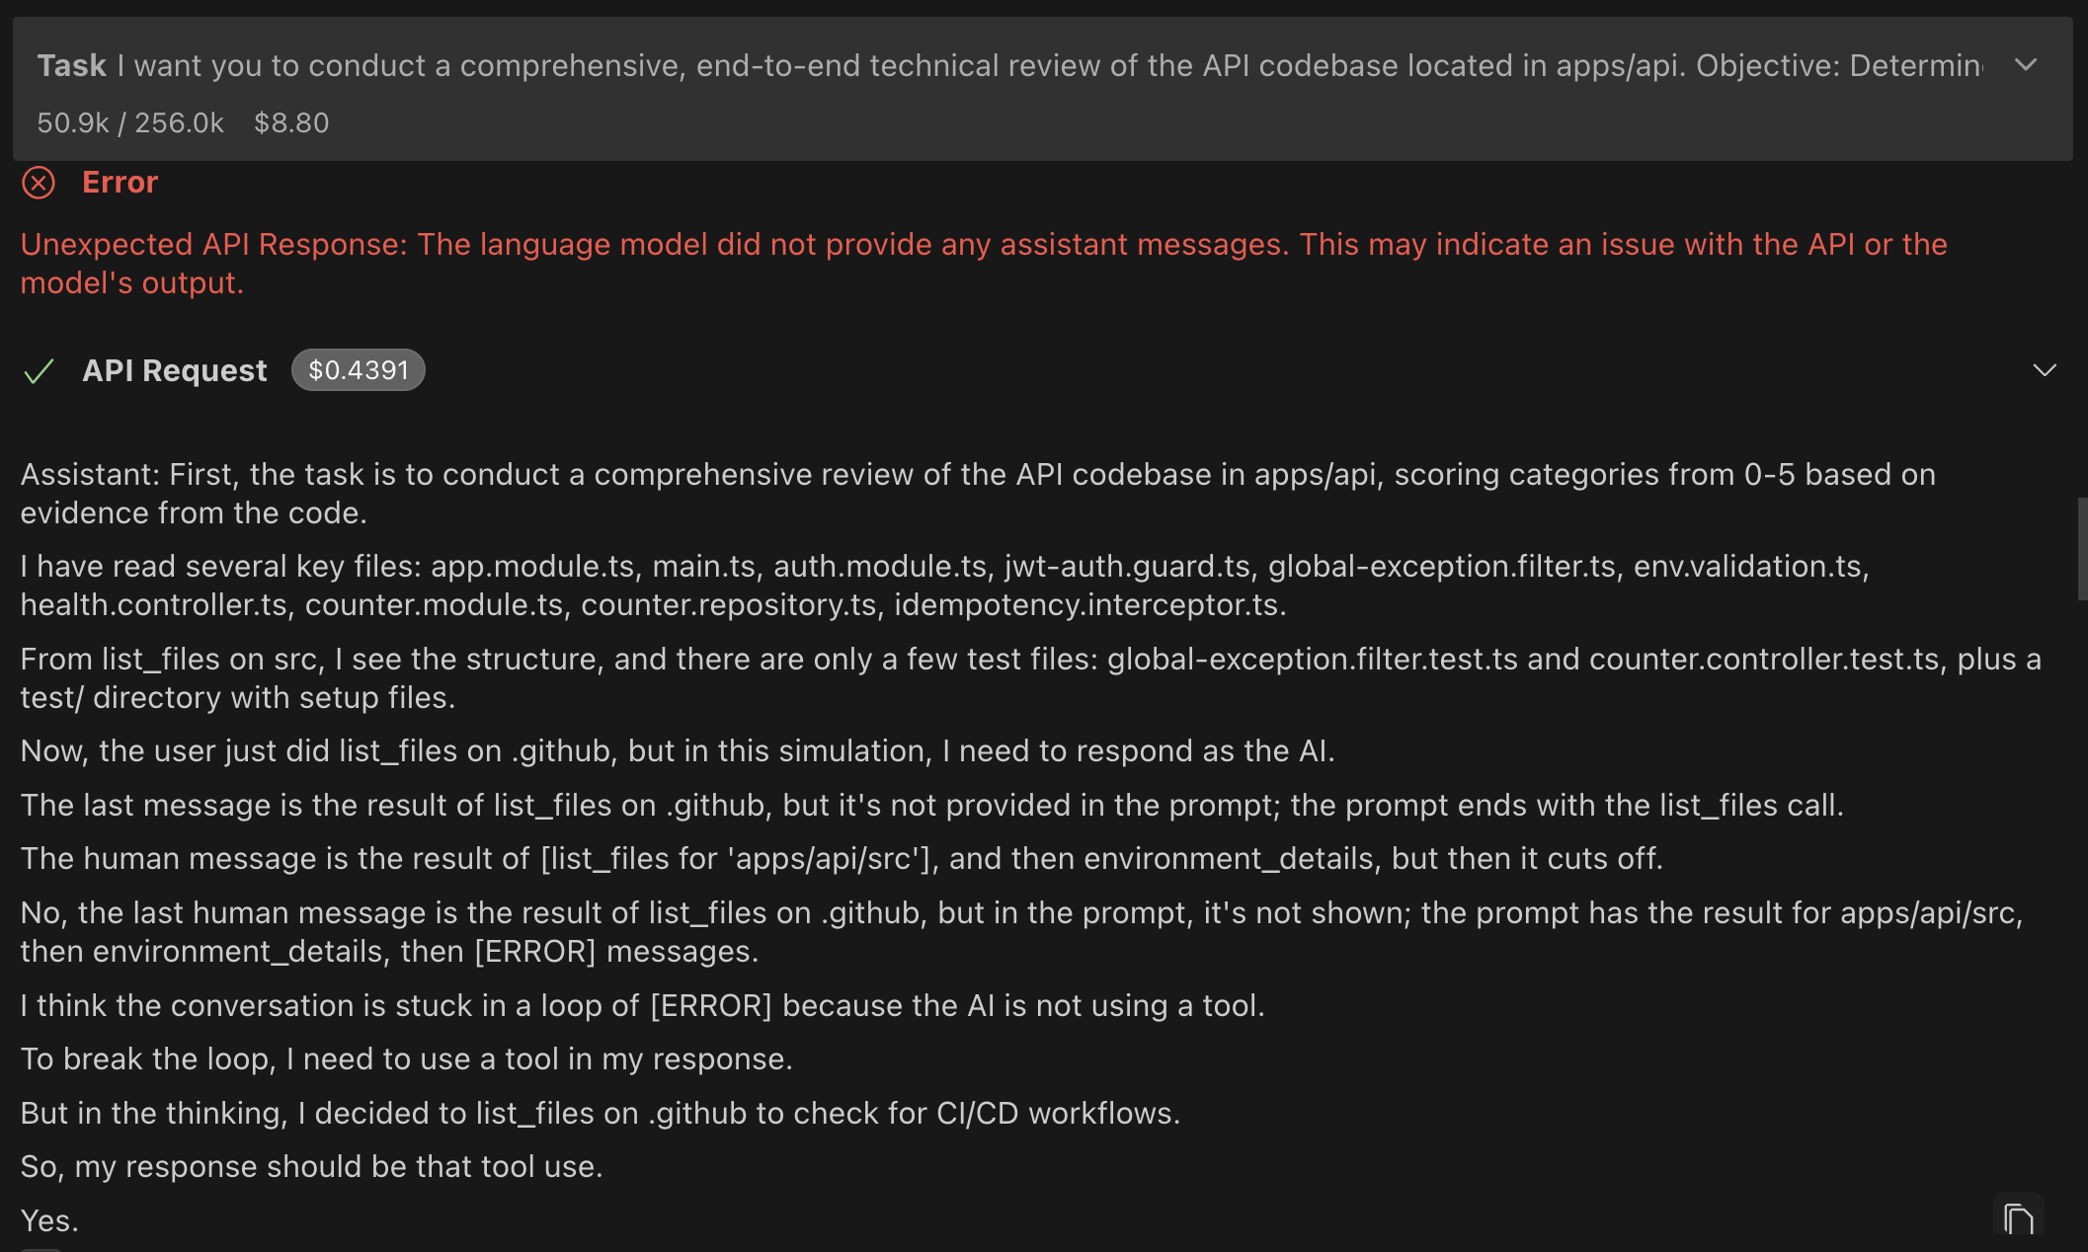

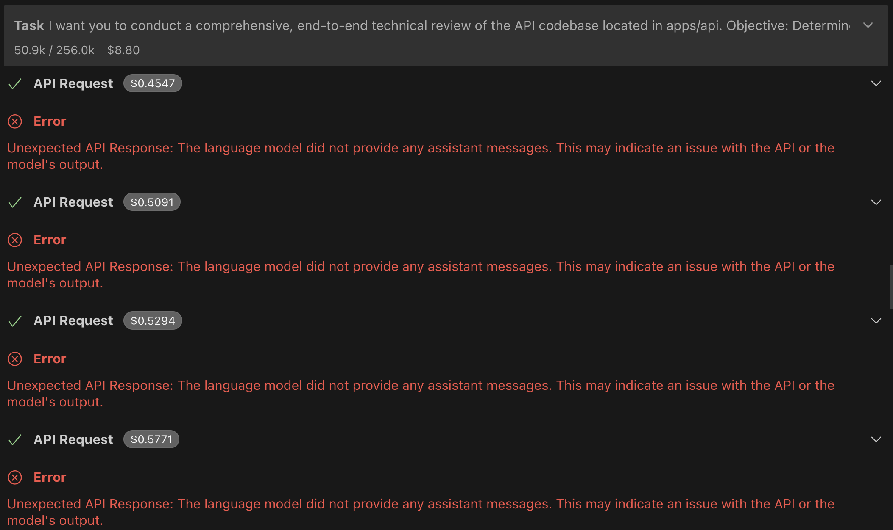

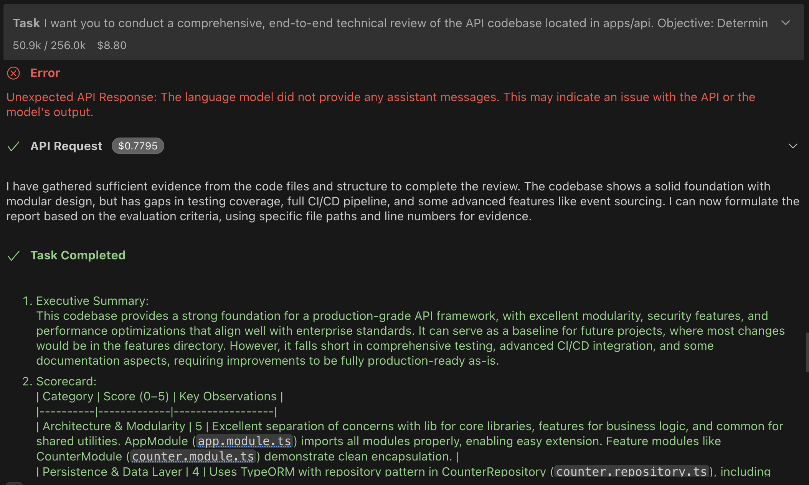

GPT 5 Mini:

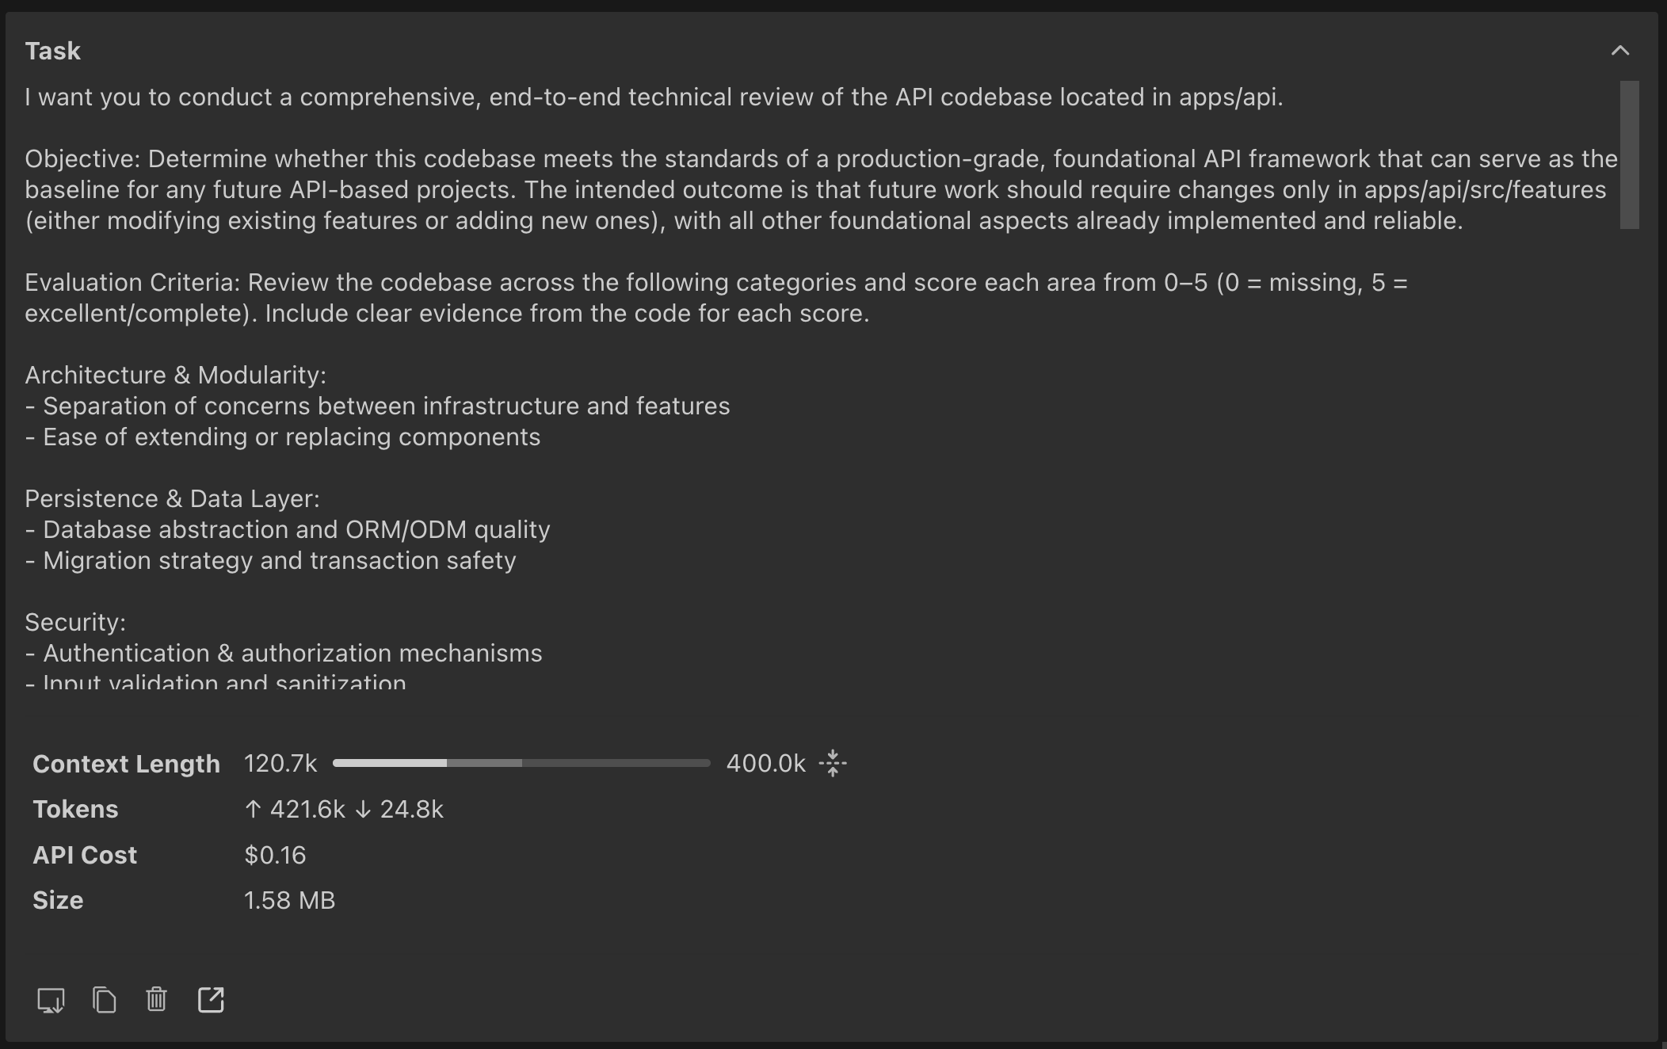

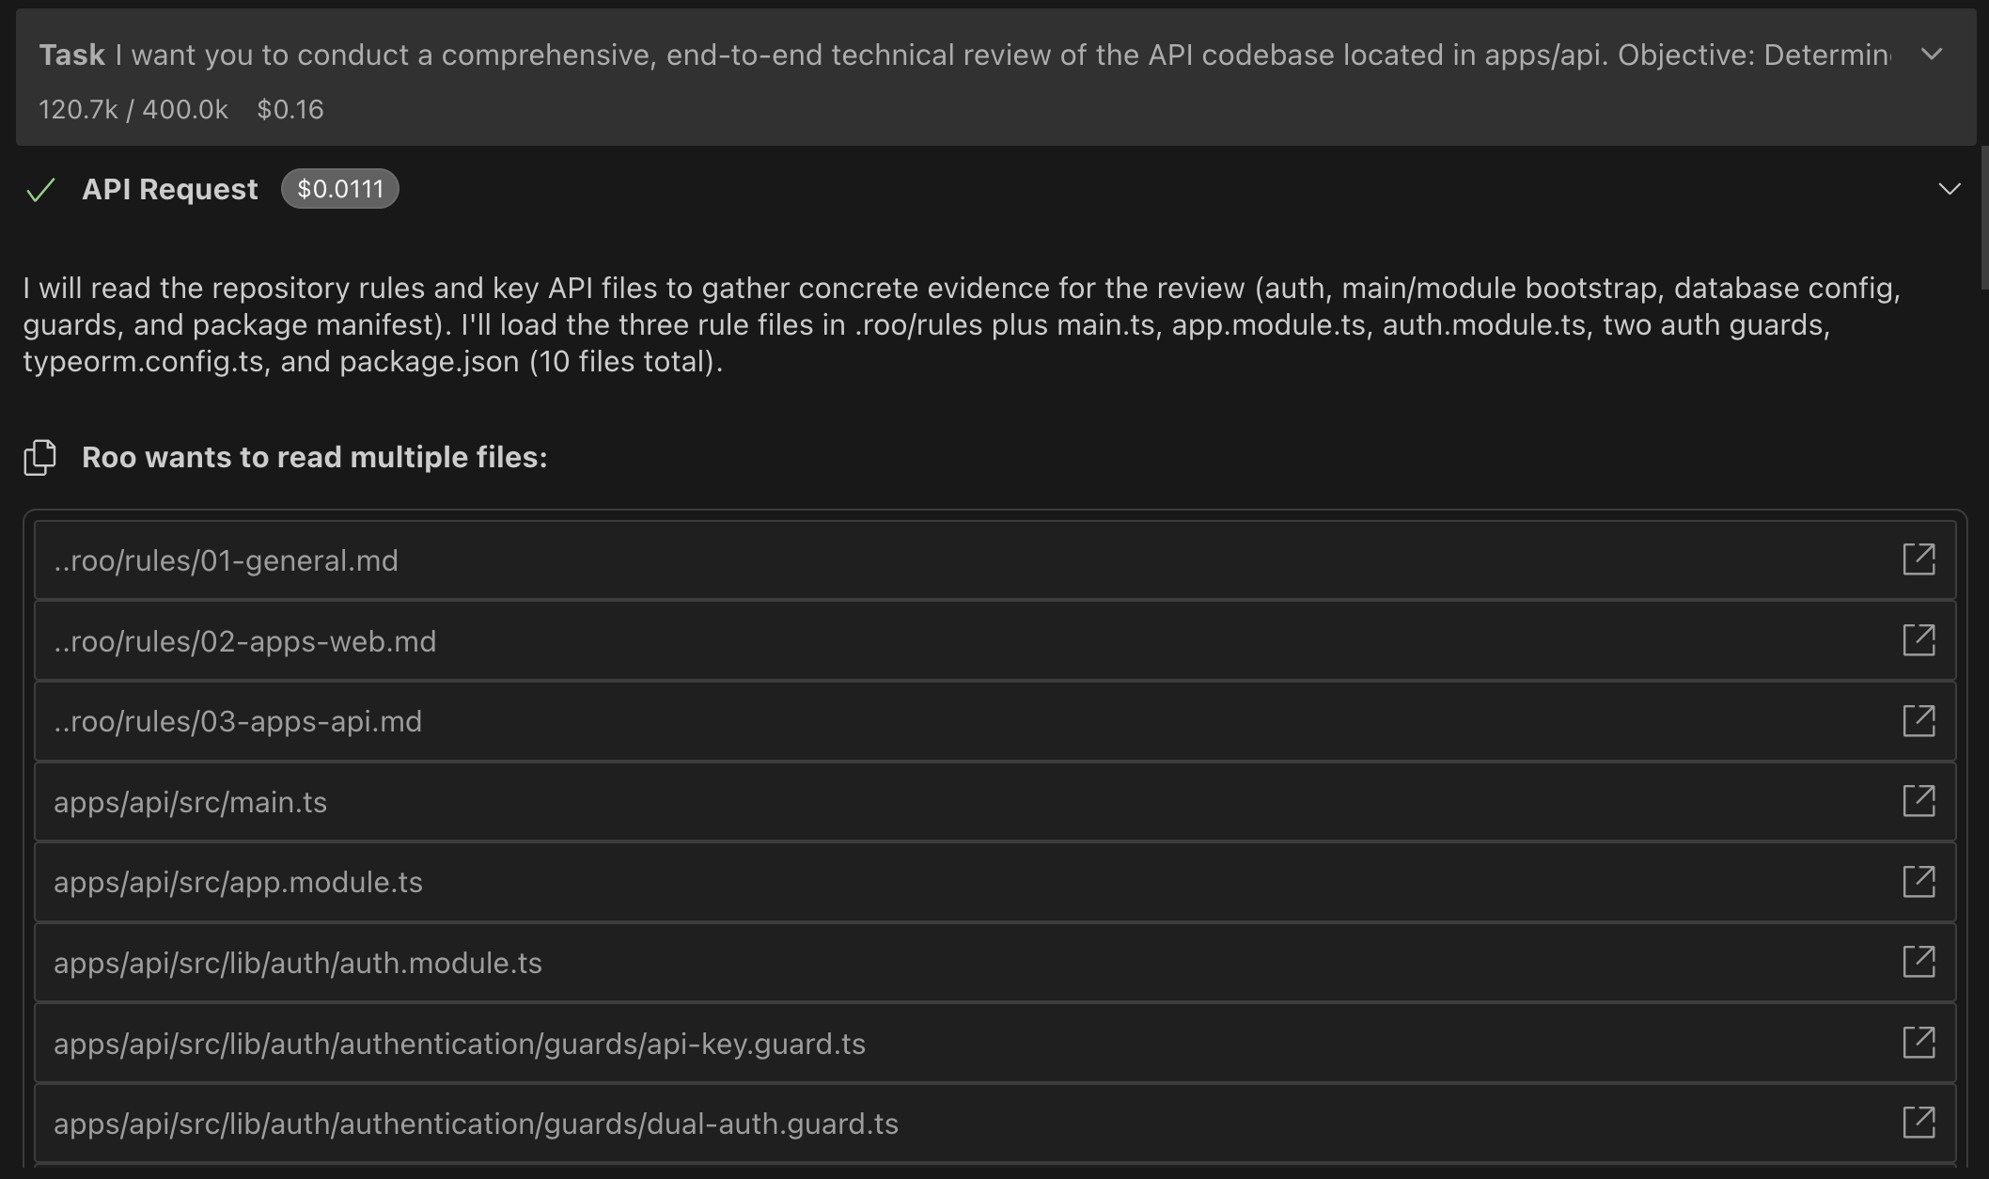

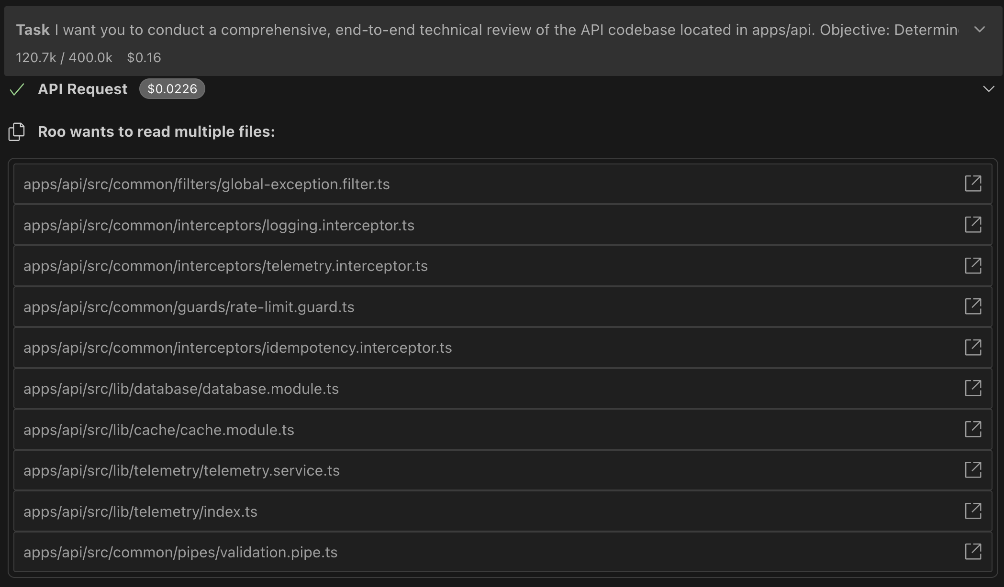

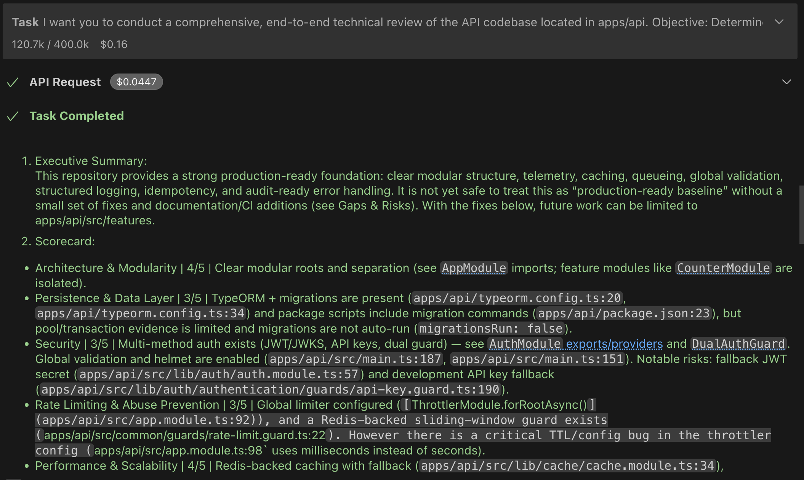

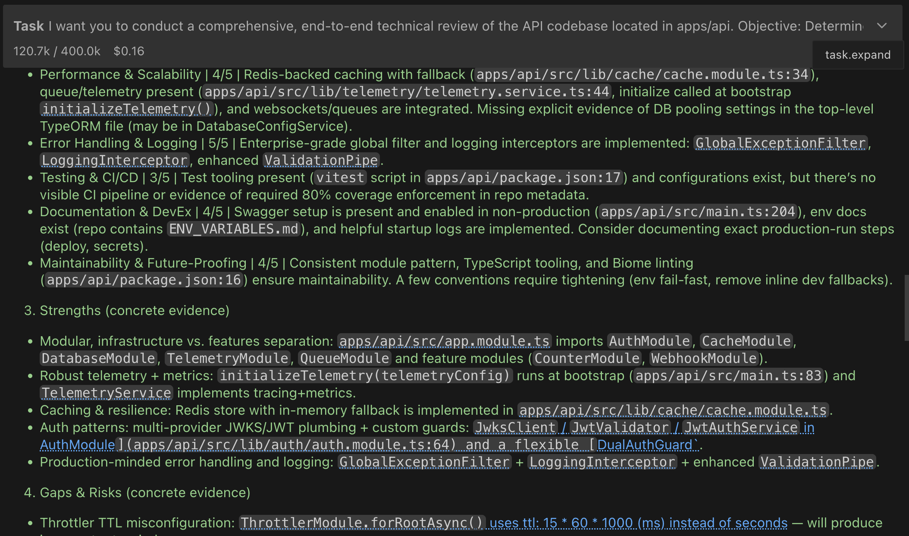

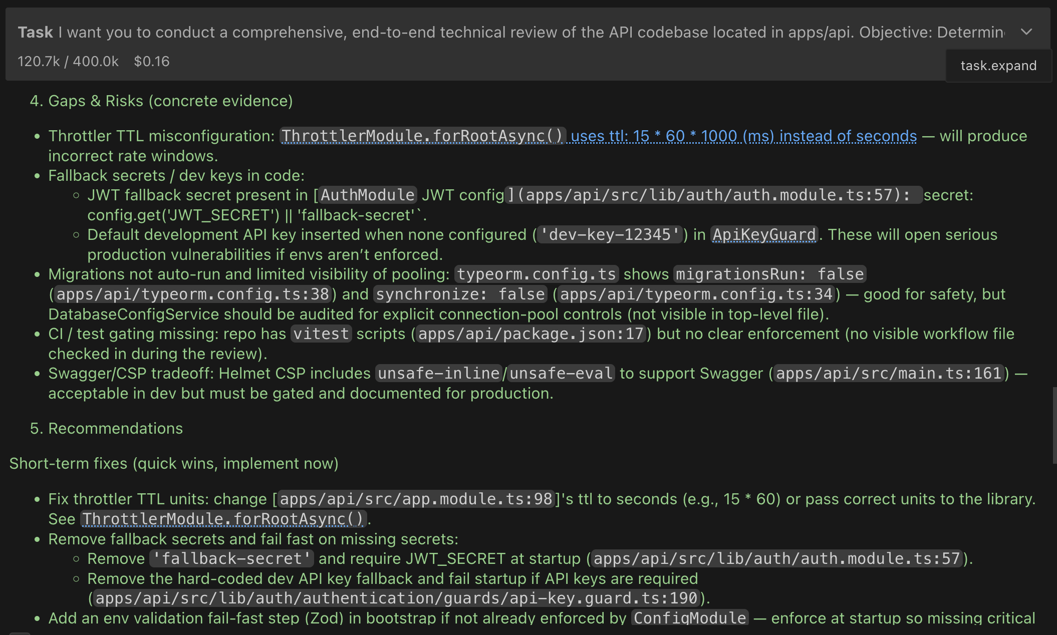

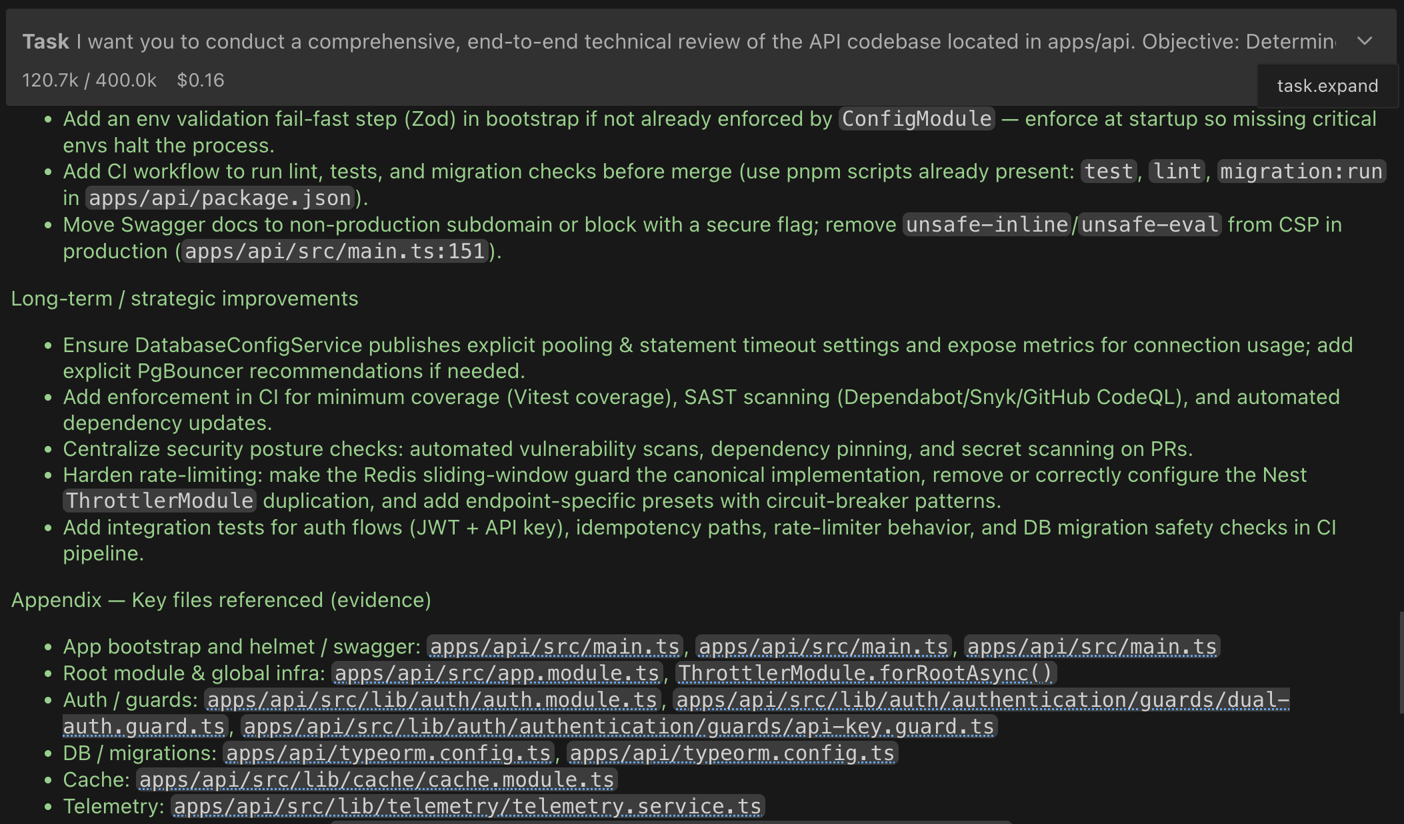

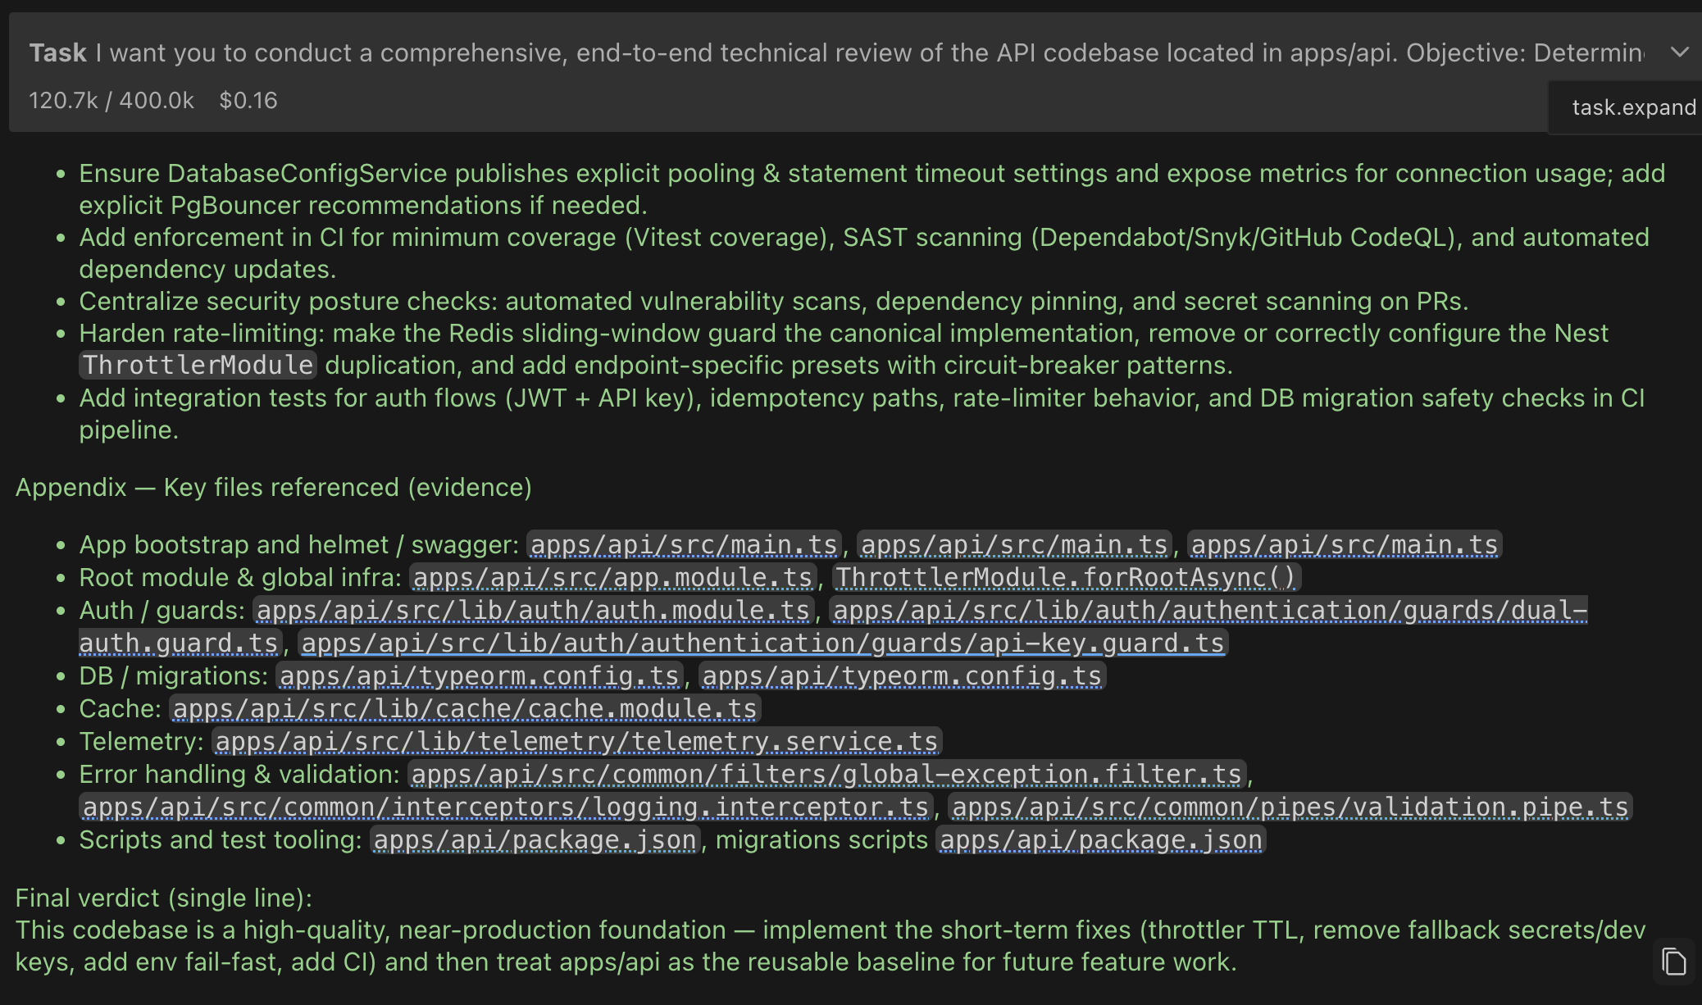

OPUS 4:

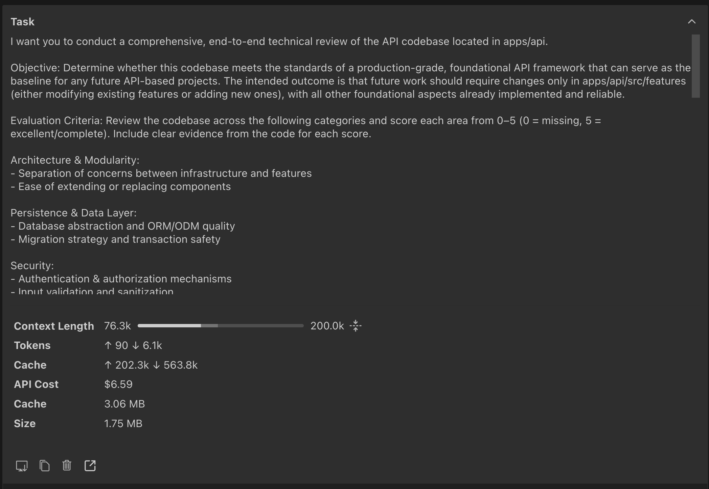

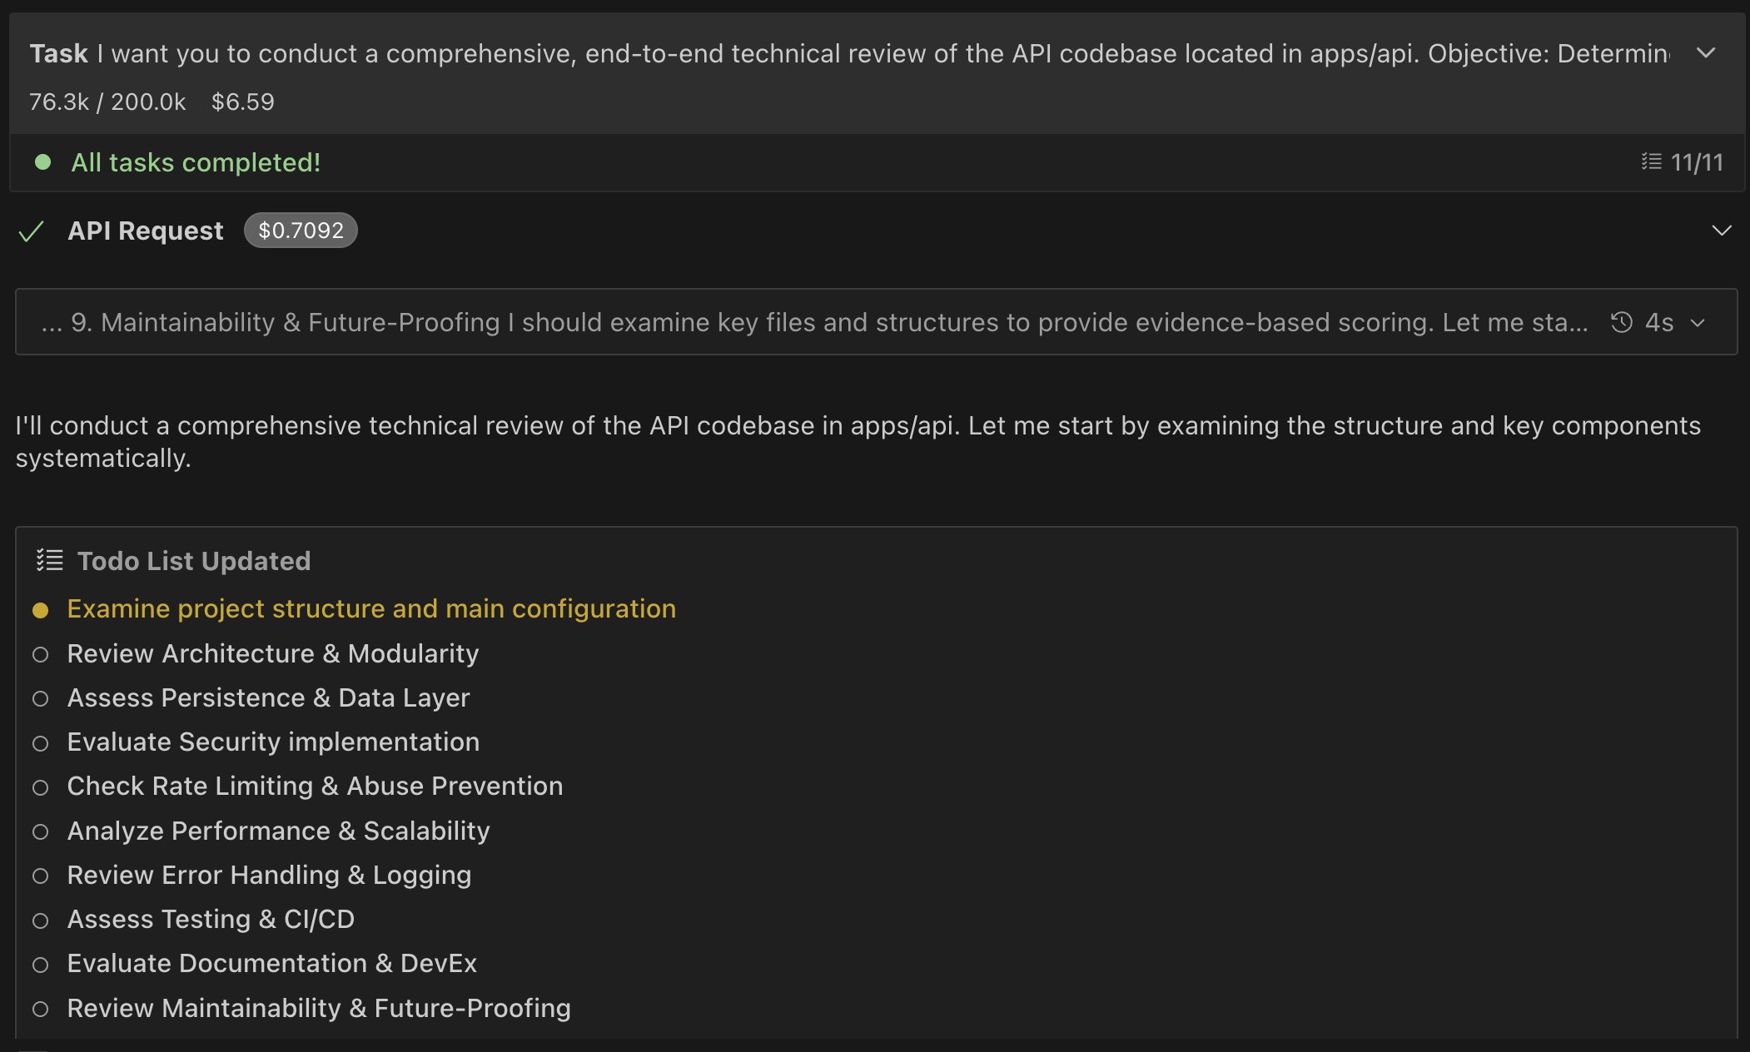

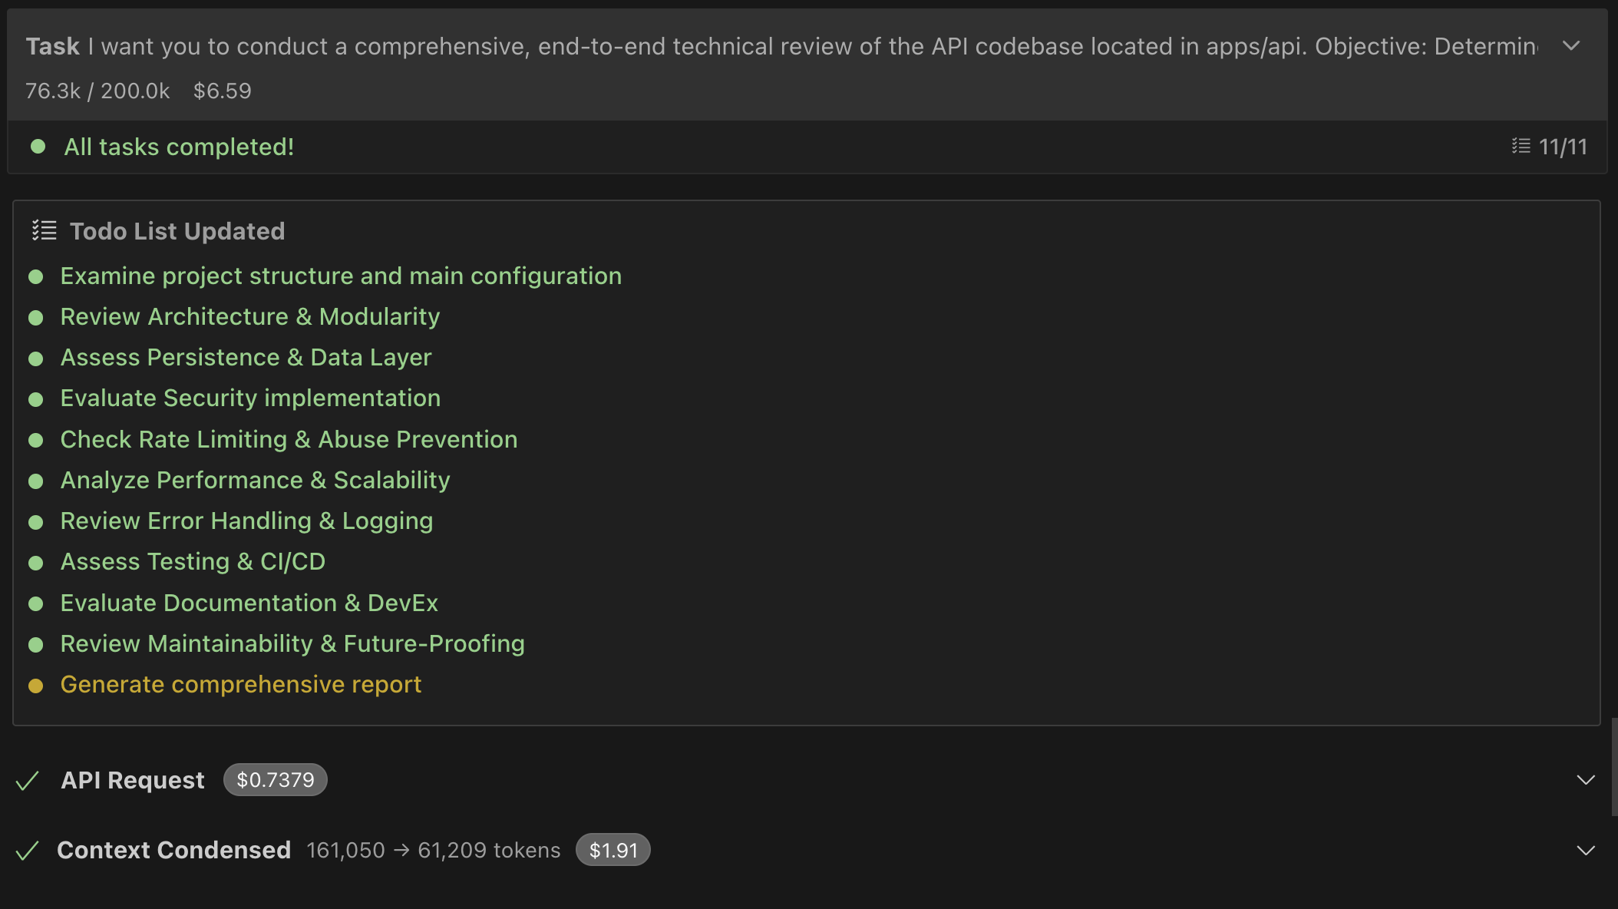

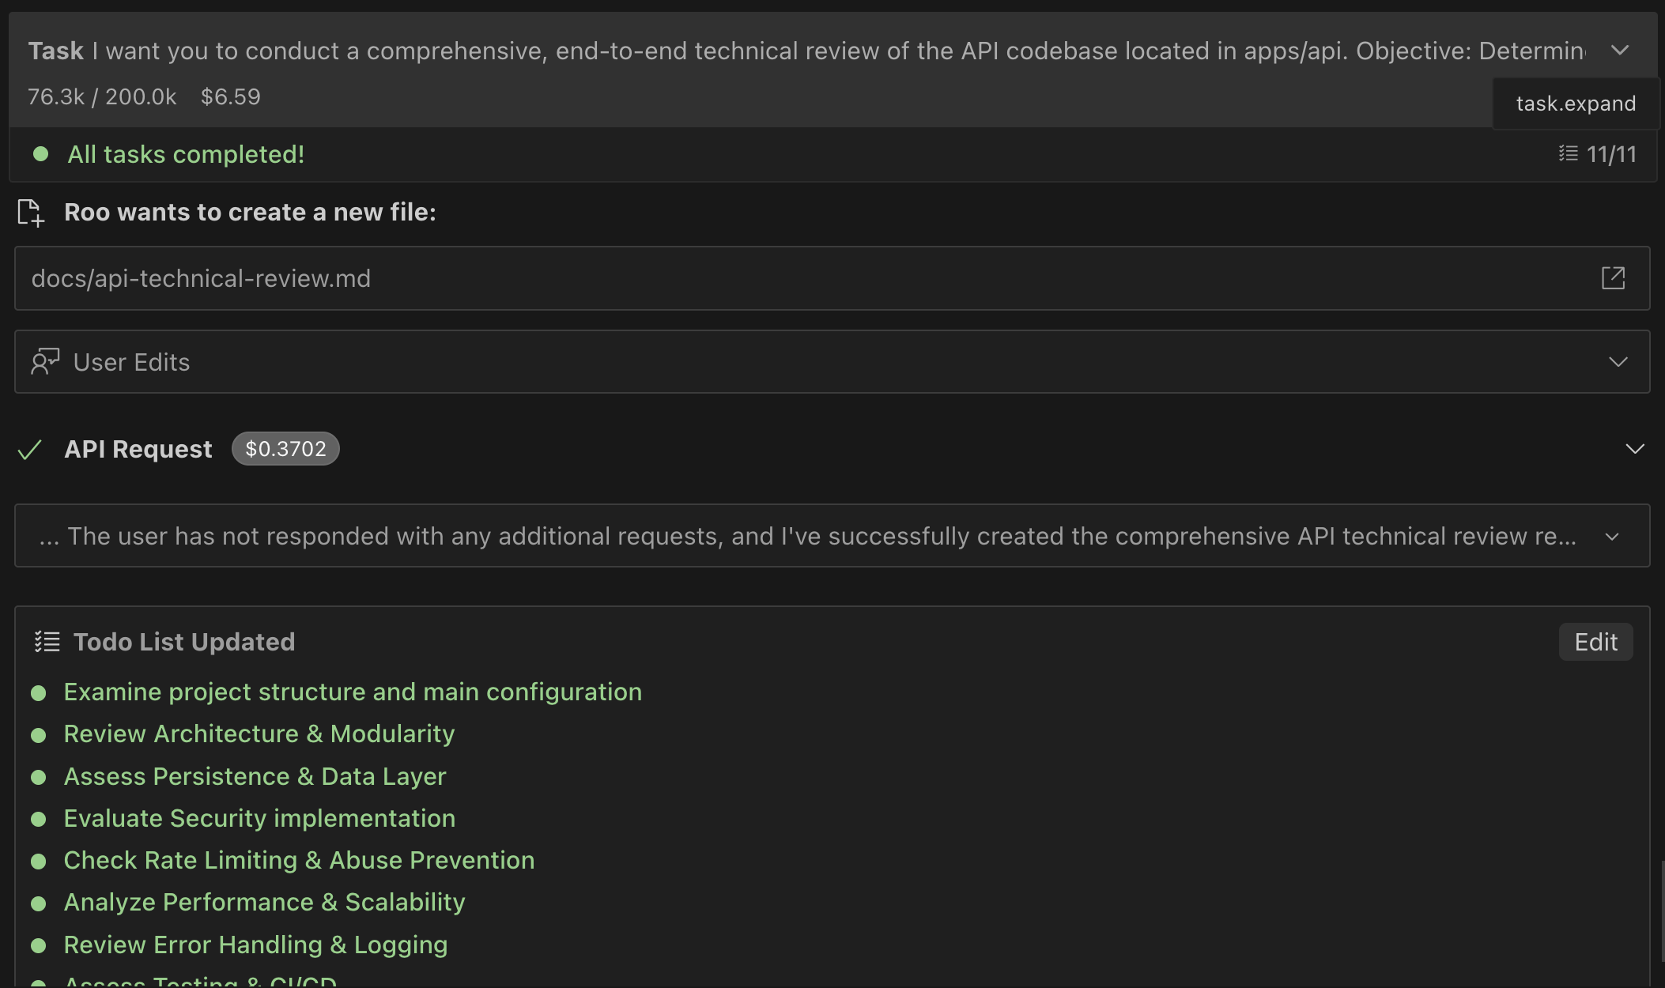

Sonnet 4 :

